123+ Instructions

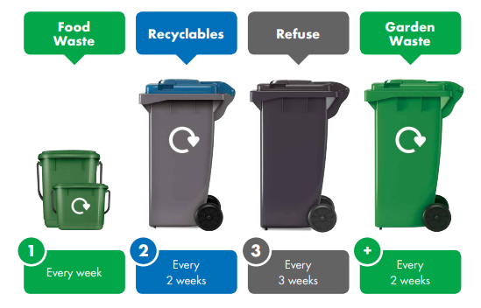
1 – Food waste collected weekly
- Residents will receive a 7-litre indoor food caddy and a 23-litre outdoor food bin.
- The indoor food caddy can be lined with compostable caddy liners or newspaper. Residents should put any peelings, raw or cooked leftover food into their caddy.
- When full, the indoor food caddy should be emptied into the outdoor food bin and the food bin presented for collection on the property boundary each week.
- The food waste is taken to an anaerobic digestion facility where it is used to create renewable energy and a soil improver.
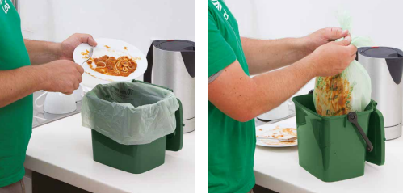
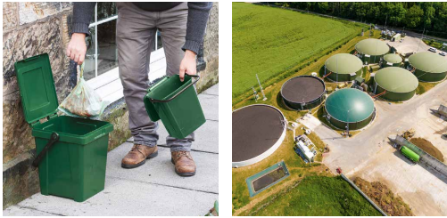

2 – Recycling collected every two weeks
- Residents should place the items below in their blue-lidded bin or recycling box for collection every two weeks:
  - All clean and dry cardboard
  - All empty, rinsed tins
  - All empty, rinsed cans
  - All empty, rinsed glass jars, with or without lids
  - All empty glass bottles, with or without metal lids (no corks)
  - All clean and dry paper
  - All empty, rinsed plastic milk bottles with or without lids
  - All empty, rinsed plastic drink bottles with or without lids
  - All empty, rinsed plastic pots, tubs and trays
  - All clean foil and foil trays
  - Empty aerosol cans (no spray paint, etc.)
  - Empty, rinsed (where possible) Tetra Pak and cartons
  - Empty, rinsed (where possible) household cleaner bottles
  - Empty, rinsed (where possible) toiletry bottles
- Recyclables must be put in the bin loose - DO NOT bag.
- Household batteries and small electrical items can be bagged, tied and put alongside the blue-lidded bin or recycling box for collection.
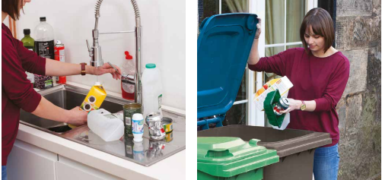
3 – Refuse collected every 3 weeks
- Only items that cannot be recycled should be placed in the grey bin.
2+ - Garden waste collected every two weeks if the resident signs up for the Garden Waste Service.
- The green bin should be used for garden waste only. No food waste.

